**LAB 3**

**Name : Vanshikaa**

**Roll No. : 102103580**

**Group : 2CO21**

**1. chr (n):**

select chr(65) from dual;

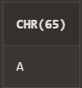

**2. cancat(char1,char2):**

select concat('Hello', 'World') from dual;

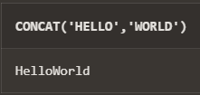

**3. instr(string,char):**

select instr('Hello World', 'World') from dual;

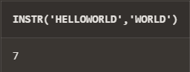

**4. length(n):**

select length('Hello World') from dual;

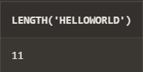

**5. lpad(char1 ,n [,char2]):**

select lpad('Hello', 10, '*') from dual;

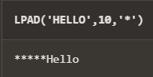

**6. ltrim(string [,char(s)]):**

select ltrim('****Hello', '*') from dual;

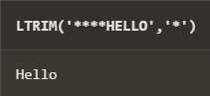

**7. rpad(char1 ,n [,char2]):**

select rpad('Hello', 10, '*') from dual;

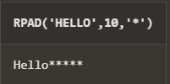

**8. rtrim(string [,char(s)]):**

select rtrim('Hello***', '*') from dual;

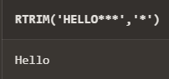

**9. replace(char ,search_string , replacement_string):**

select replace('Bleck Cet', 'e', 'a') from dual;

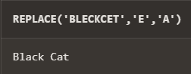

**10. substr(string ,position ,substring length):**

select substr('Hello World', 7, 4) from dual;

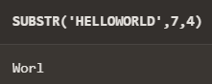

**11. initcap(char):**

select initcap('hello world') from dual;

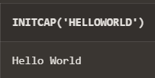

**12. lower(string):**

select lower('HELLO woRlD') from dual;

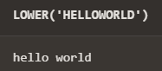

**13. upper(string):**

select upper('HELLO woRlD') from dual;

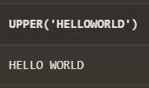

**14. translate(char ,from string ,to string):**

select translate('BBBBCCDDEFG', 'BCD', 'DEC') from dual;

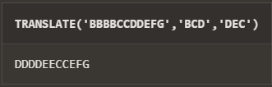

**15. abs(n):**

select abs(-31) from dual;

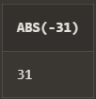

**16. ceil(n):**

select ceil(45.3) from dual;

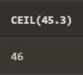

**17. cos(n):**

select cos(0) from dual;

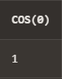

**18. exp(n):**

select exp(1) from dual;

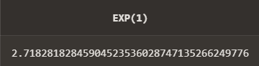

**19. floor(n):**

select floor(303.32) from dual;

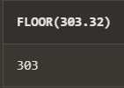

**20. mod(m ,n):**

select mod(10, 3) from dual;

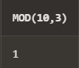

**21. power(x ,y):**

select power(2, 5) from dual;

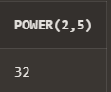

**22. round(x [,y]):**

select round(30.56) from dual;

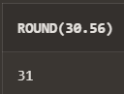

**23. sign(n):**

select sign(332) from dual;

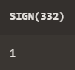

**24. sqrt(n);**

select sqrt(25) from dual;

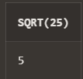

**25. trunc(x ,n):**

select trunc(25.123) from dual;

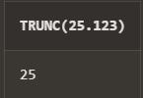

**26. sysdate:**

select sysdate from dual;

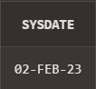

**27. add_months(d ,n):**

select add_months(sysdate, 2) from dual;

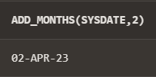

**28. last_day():**

select last_day(sysdate) from dual;

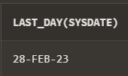

**29. months_between(date1 ,date2):**

select months_between(sysdate, sysdate+60) from dual;

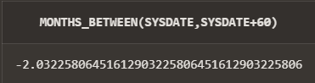

**30. next_day(date ,char):**

select next_day(sysdate, 'TUESDAY') from dual;

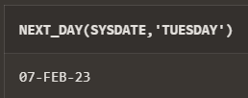

**31. greatest(expr): 32. least(expr):**

select greatest(1, 2, 3, 4, 5) from dual;

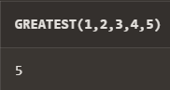

**32. least(expr):**

select least(1, 2, 3, 4, 5) from dual;

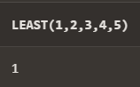

**Q2) Display current time in hour : min : sec format**

select to_char(current_timestamp, 'HH24:MI:SS') from dual;

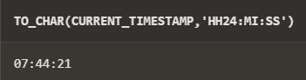

create table empl(

empno number,

ename varchar(25),

job varchar(25),

salary number,

commission number,

deptno number,

hiredate date

);

insert into empl values (1,'Rishabh', 'Salesperson',2500,100,10,NULL);

insert into empl values (2,'Abhinav', 'Clerk',1500,NULL,10,NULL);

insert into empl values (3,'Abha', 'SDE',2700,NULL,30,NULL);

insert into empl values (4,'Aryan', 'Salesperson',2500, NULL,10, NULL);

insert into empl values (5,'Pranjay', 'Salesperson',2500,NULL,10,NULL);

insert into empl values (6,'Varun', 'Clerk',2100,100,20,NULL);

**Q3) Display salary + commission of emp table**

select salary + commission from empl where commission is not null;

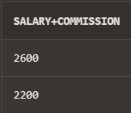

**Q4) Store any date value in hiredate column of table ?**

update empl

set hiredate = to_date('29-11-1985','DD-MM-YYYY')

where ename = 'Rishabh';

update empl

set hiredate = to_date('29-11-2023','DD-MM-YYYY')

where ename = 'Varun';

**Q5) Display name of employee(s) who join the company in 1985 ?**

select ename from empl where TO_CHAR(hiredate,'YYYY') = '1985';

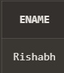

**Q6) Display name of the employee(s) who join the company this year ?**

select ename from empl where TO_CHAR(hiredate,'YYYY') = TO_CHAR(sysdate,'YYYY');

